附件2

“我的校园故事”征文活动说明
（英文版）
Introduction of “My Campus Story” storytelling contest

China Daily and its Study China platform (studychina.chinaservicesinfo.com) are holding a storytelling contest. International students who study or used to study in China are welcome to share their campus life.
WORKS IN THREE CATEGORIES
i. Articles
ii. Photos
iii. Videos
Languages in either English or Chinese are preferred.
AWESOME PRIZES
We offer prizes worth up to 10,000 yuan (approximately $1,563). Winners will be awarded certificates and prizes by the organizers. Some of the best works get a chance to be featured on China Daily app (with 36 million users) and studychina.chinaservicesinfo.com.
WHEN TO SUBMIT
Opens on April 11, 2022-Submission deadline: May 31, 2022
HOW TO PARTICIPATE
Articles and photos
● Article: 300 - 1,000 English or Chinese words
● Photo: 10 photos maximum, 5MB for each; each with a caption up to 200 English words; format in JPG or PNG.
Videos
● Format: MP4 or MOV
● Size: 1GB maximum, up to 4 minutes.
● Caption: 200-500 English words to give a brief introduction.
SUBMIT HERE
You can submit your works by:
1. China Daily app: download the China Daily app in the App Store, search for and find "My Campus Story" on the app’s homepage, and then click to submit your work.
2. logging on to the website:
https://studychina.chinaservicesinfo.com/mycampusstorysubmit/
3. Scanning the QR code below
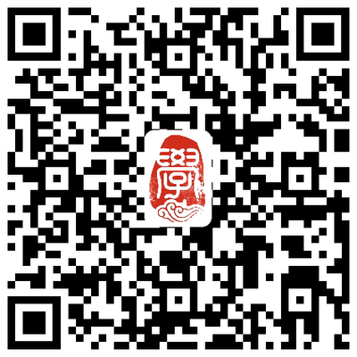

COPYRIGHT STATEMENT
The entries should not involve any pornography, violence, reactionary elements or commercial advertisements.

The author owns the copyright and has the right of authorship of the entries. Once the entries are published on the contest website, it means the author has agreed that China Daily has the right to edit their works before publishing them online. Also, China Daily has the right to use their works in other capacities for free, such as internet, cable TV, and mobile terminals, also publications, posters and exhibitions.

All participants should guarantee ownership of copyright of their entries, or that they have the right to authorize the use of entries in competitions, promotions and screenings. The author(s) shall bear all legal responsibilities and economic losses, including but not limited to those resulting from the products' infringement of intellectual property, portrait rights and reputation rights, as well as defamation and other violations of laws and regulations.

By entering the contest, entrants will be deemed to have accepted and be bound by the terms and conditions. China Daily reserves the right to interpret the terms and conditions of the contest.

