CIRD-F: Spread and Inﬂuence of COVID-19 in China
ZHOU Lingyunª (周凌云), WU Kaiwei^{b} (吴凯伟), LIU Hanzhi^{c} (刘涵之),GAO Yuanning^{c} (高远宁), GAO Xiaofeng^{c}∗ (高晓沨)
( a. Antai College of Economics and Management; b. SJTU-ParisTech Elite Institute of Technology; c. School of Electronic Information and Electrical Engineering, Shanghai Jiao Tong University, Shanghai 200240, China)
Abstract: The outbreak of coronavirus disease 2019 (COVID-19) has been spreading rapidly in China and the Chinese government took a series of policies to control the epidemic. Therefore, it will be helpful to predict the tendency of the epidemic and analyze the inﬂuence of oﬃcial policies. Existing models for prediction, such as cabin models and individual-based models, are either oversimpliﬁed or too meticulous, and the inﬂuence of the epidemic was studied much more than that of oﬃcial policies. To predict the epidemic tendency, we consider four groups of people, and establish a propagation dynamics model. We also create a negative feedback to quantify the public vigilance to the epidemic. We evaluate the tendency of epidemic in Hubei and China except Hubei separately to predict the situation of the whole country. By changing the parameters of the model accordingly, we demonstrate the control eﬀect of the policies of the government on the epidemic situation, which can reduce about 68% possible infections. At the same time, we use the capital asset pricing model with dummy variable to evaluate the eﬀects of the epidemic and oﬃcial policies on the revenue of multiple industries.
Key words: coronavirus disease 2019 (COVID-19), epidemic prediction model, negative feedback, capital asset pricing model, dummy variable
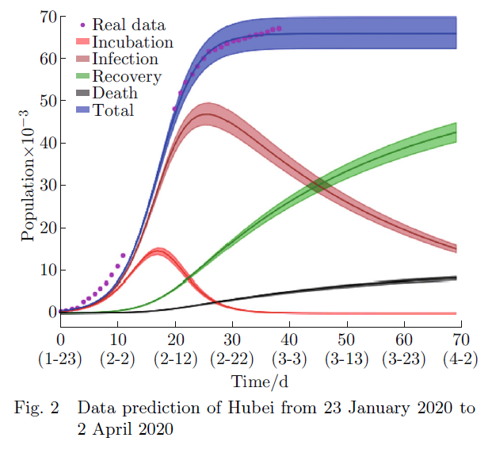
References（另列1页）:

